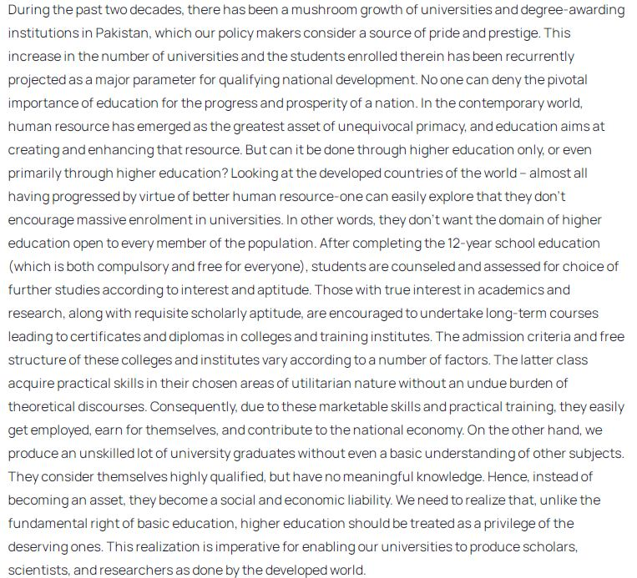

Q1: what can be inferred from the passage as the main goal of education?

Q2: What is the benefit of guiding students in the choice of careers?

Q3: Is the only direct question in passage answered affirmatively or negatively?

Q4: Which sentence do you think seems to be the topic sentence of the paragraph, capturing its central point?

Q5: Which sentence looks redundant and out of place in the context of paragraph, seeming a later addition rather than part of original?